An Illustrated table of the fig wasps

developing in figs of Ficus nr treubi
in Xishuangbanna (China)
by Jean-Yves Rasplus (INRA, France)

Ficus nr treubi
Ceratosolen sp.n. or idem C. (squamosa) | 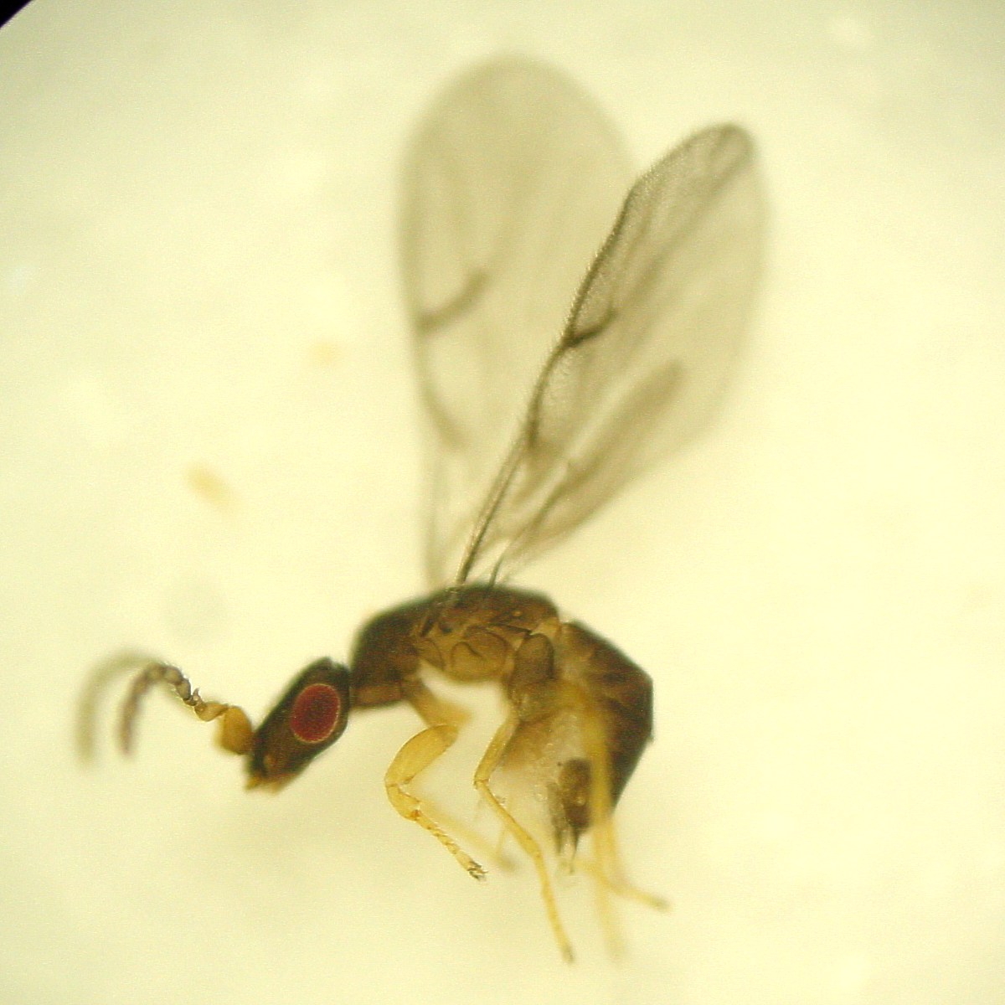 | 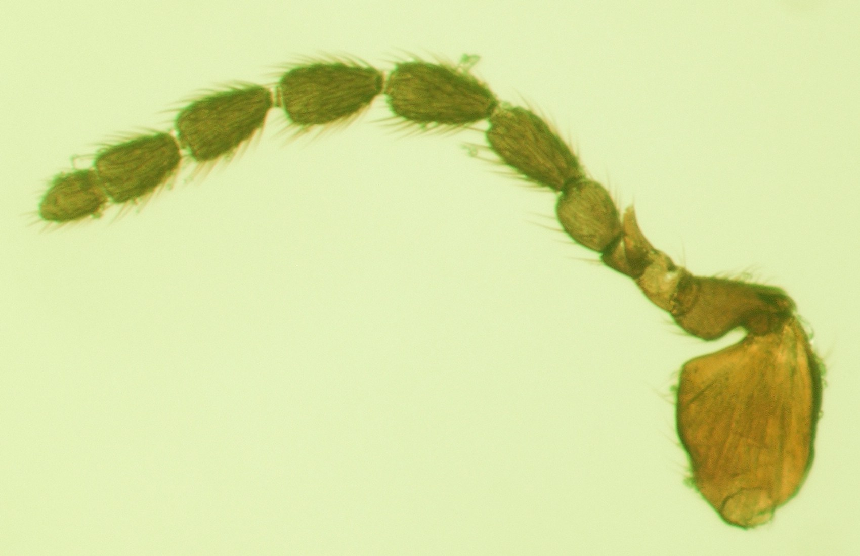 | 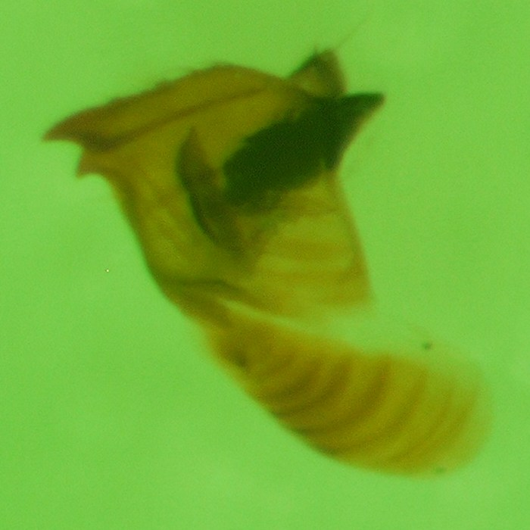
Ceratosolen sp. | 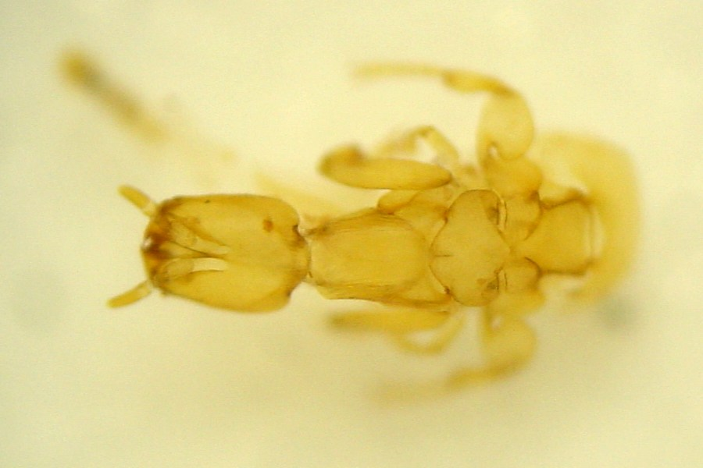 | 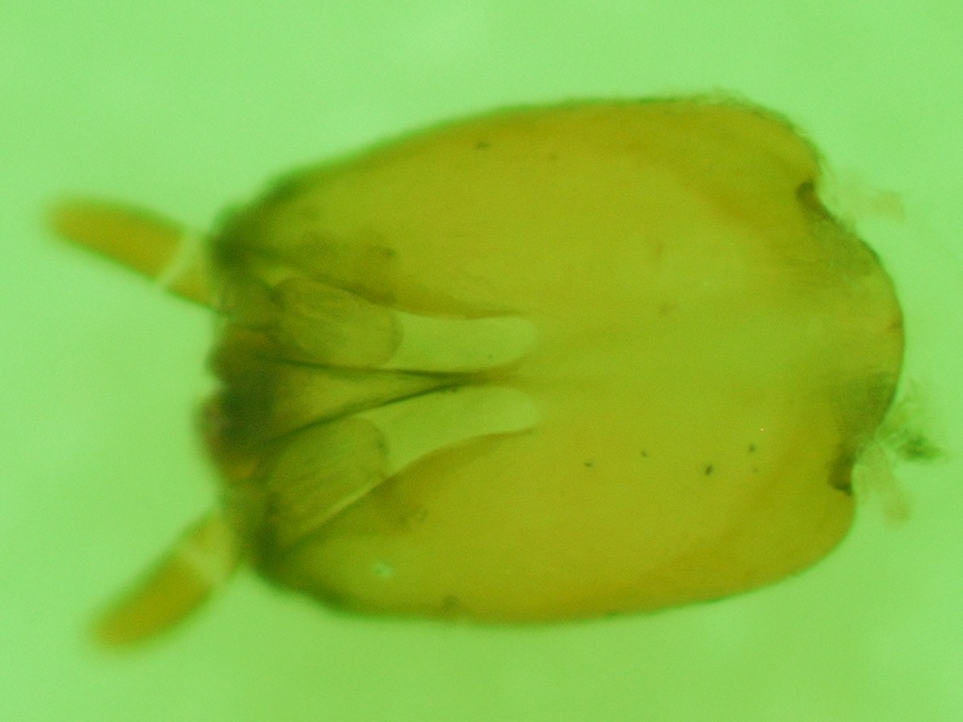 | 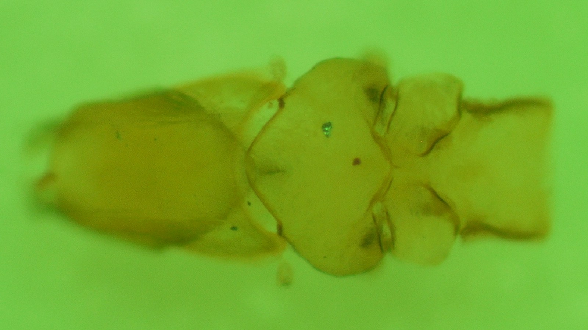
Platyneura sp. ? | 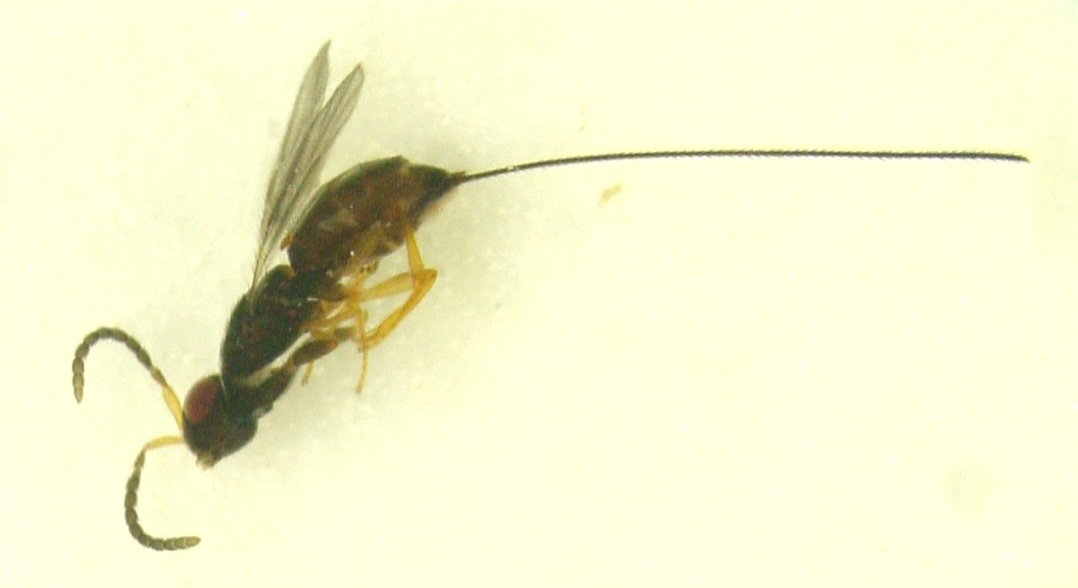 | 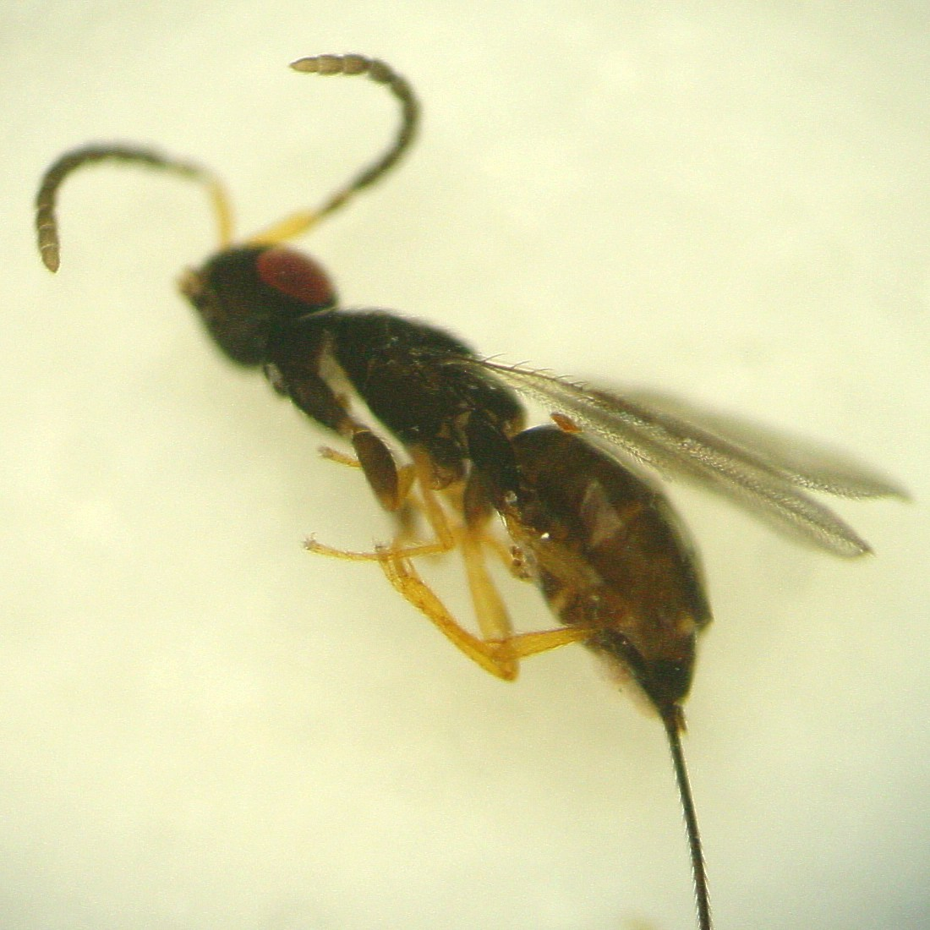 | 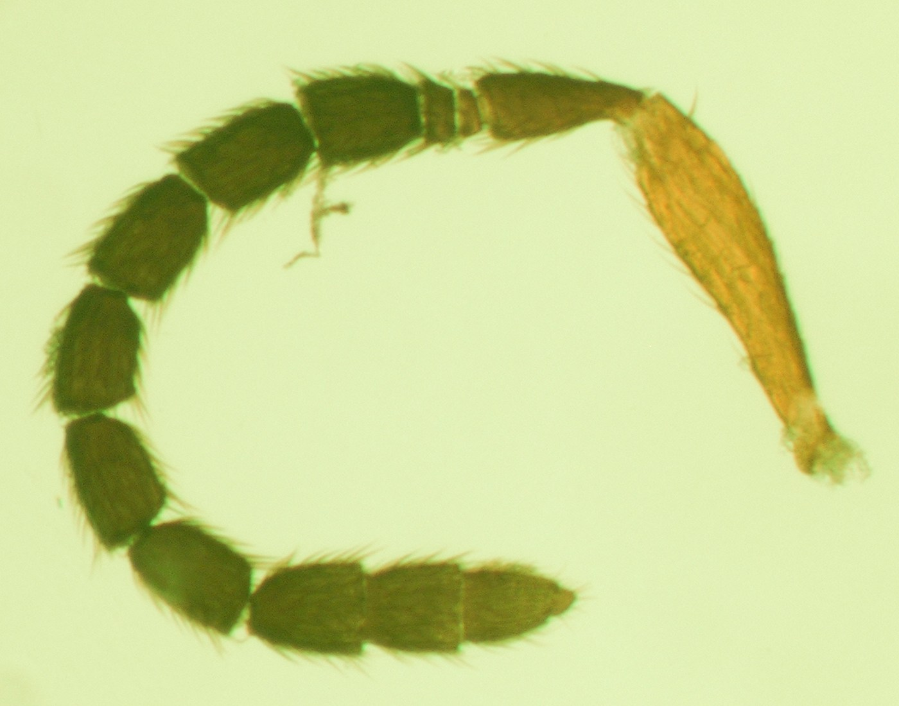
Platyneura sp. ? | 